A Search Aware Machine Learning Approach for E-Commerce Demand Forecasting
Dr. Rushikesh Rajendra Nikam
Department of Computer Engineering
A. P. Shah Institute of Technology
Mumbai, India
rrnikam@apsit.edu.in

Rupali Pratap Biradar
Department of Computer Engineering
A. P. Shah Institute of Technology
Mumbai, India
rupalibiradar010@gmail.com
Deepak Subhash Khachane
Department of Computer Engineering
A. P. Shah Institute of Technology
Mumbai, India
dskhachane@apsit.edu.i

Avanish Ravindra Kasar
Department of Computer Engineering
A. P. Shah Institute of Technology
Mumbai, India
avanishkasar57@gmail.com

Abstract—Despite advancements in time series analysis, demand forecasting in e-commerce continues to be a difficult task since conventional approaches may not account for unexpected shifts in customers' search habits, interests, and overall economic circumstances. In this paper, an end-to-end forecasting system is introduced to use both historical information on products as well as Google Trends to enhance demand predictions and inform decision-making regarding launching products at the right time and setting appropriate prices. As a result, SARIMA and XGBoost were chosen as two models that represent the base and improved versions, respectively, to consider sales like patterns in time and seasonality, in addition to engineered features such as lagged demand, price, seasonality, and trend. Furthermore, a CSV pipeline was designed to analyse uploaded datasets to ensure validity, detect categories, match trends, and generate results through visualization. The framework is tested using baseline and improved models based on standard forecasting techniques such as MAE, RMSE, and MAPE. Findings suggest that the use of search intent from external sources increases forecasting accuracy and improves decision-making compared to forecasts generated using only historical information. Besides forecasting, the approach is also capable of determining the optimal time frame for launching new products as well as making price-related decisions aimed at generating more income. As a result, it becomes possible to apply this approach in the context of operations management in e-commerce. This paper proves that freely available information on trends may become an efficient addition to sales data and present a scalable and decision-oriented approach for product demand analysis. Finally, combining research notebooks with interactive applications allows bridging the gap between forecasting methods applied in academic studies and decision support tools used in practice.
Keywords—E-commerce forecasting, Google Trends, SARIMA, XGBoost, demand prediction

Introduction
Online shopping in India has rapidly increased in the last ten years, and electronics and accessories have played a major role in this growth. Websites like Amazon India and Flipkart often experience significant spikes in demand during sale events, such as Diwali, Republic Day, and mid-year sales. Anticipating these busy periods a few weeks in advance can greatly improve planning for stock levels, pricing, and product launches.

However, many sellers, especially smaller and medium-sized ones, still rely on intuition or simple moving averages when planning inventory. Even larger operators who employ forecasting models tend to depend solely on historical sales data, without incorporating signals about what consumers are actively searching for. This presents a clear challenge: by the time a surge in demand appears in sales figures, it is often too late to respond effectively. Stock may have already run out, prices may have been set suboptimally, or a competitor may have captured the market with a better-timed launch.
This is where Google Trends becomes valuable. Each week, millions of people in India search for terms like "earbuds india," "wireless earphones," or "Bluetooth earbuds under 2000." These searches occur before someone makes a purchase. Therefore, Google Trends data can indicate future demand that has not yet been reflected in sales figures. If the signal is strong and consistent enough, it can help a prediction model forecast upcoming trends instead of merely reacting to the past.
The main question we address in this paper is whether incorporating Google Trends search data into a machine learning model significantly improves demand predictions for electronics on Indian e-commerce sites. If so, we explore how to use that improvement for practical decisions regarding product launches, pricing, and inventory management.

Related Work
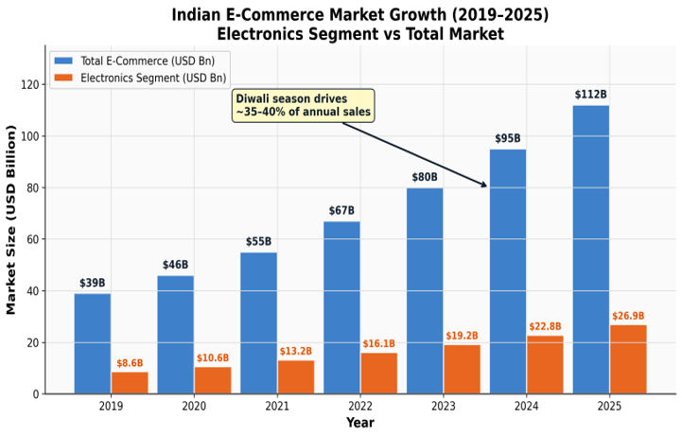
Fig. 1. Growth of the Indian e-commerce electronics market (2019-2025), illustrating the seasonal demand peaks that motivate this research. Source: Industry reports / IBEF data.
This section presents an overview of the literature on the foundation of our suggested system. The topic of demand forecasting has extensive background knowledge based on time-series analysis [5, 14], long considered a gold-standard technique for capturing sales patterns over time. More recent research into web search analytics [1, 7], in particular Google Trends, has revealed its capability to detect consumers' intent. Meanwhile, advances in machine learning, such as gradient boosted models [3] and deep learning neural networks [11, 12, 17], allow forecasters to consider a broader set of features with non-linear interactions that traditional approaches do not account for. We present the discussion based on three main threads of literature mentioned above, complemented by a brief overview of the Indian e-commerce context relevant to our research. Fig. 1 depicts the growing trend of the Indian electronics market within e-commerce and identifies the seasonal spikes that necessitate our research focus. Figure 1. Indian e-commerce electronics market growth (2020–2025), showing the seasonal patterns driving this study. Source: Industry reports / IBEF data.

From Fig 1, the growth trends in the Indian e-commerce electronics market have been steady from year to year. However, there is a spike in demand for this product in certain festive seasons like the Diwali season (October–November) and the Republic Day sales (January). The significance of considering these seasonal factors is emphasised throughout the review.

- Google Trends as an Economic Indicator

Interest in the use of search-related datasets for economic forecasting emerged in the early mid 2000s. The initial questions concerned the potential ability of Google queries to help predict the dynamics of various macroeconomic aggregates within seconds after their actual values became known. The pioneering contribution by Choi and Varian [1] demonstrated that the use of Google Trends data helped forecast housing prices, car sales, unemployment benefits claims, and tourist arrivals better. Specifically, the authors pioneered a general paradigm of nowcasting – estimation of the current value of the economic variable based on search signals as a proxy for real-time consumers' intents. A large body of research has been dedicated to evaluating the effectiveness of nowcasting in various economic sectors. For instance, Goel et al. [7] evaluated whether Google queries can be used to nowcast movie box office revenue, sales of video games, and song popularity. The authors showed that search data can help produce relevant base-level forecasts but provided little value in terms of improvement compared to simpler models, and the effects varied across domains. Montgomery et al. [14] give a complete exposition of the statistical background of the time series analysis approach on which much of nowcasting research is based.

Although the papers discussed above have shown the viability of web search information as an economic barometer, its usage for retail forecasts needs specific domain-related customisation. The subsequent subsection discusses studies that address this limitation by utilising Google Trends for estimating demand for individual products.

- Search Data in Retail Forecasting

One of the most comprehensive analyses of Google Trends used in predictive modelling of retail sales was carried out by Boone, Ganeshan, and Hicks [2]. They found statistically significant decreases in MAPE from Trends in consumer goods when integrated into normal demand models. In particular, one very interesting practical observation they had is that search-based indicators can provide their largest gain in accuracy when there is a change in the demand pattern—in other words, a change in structure such as introducing a new product line, or surprising events, etc., instead of a period when demand is fairly stable. This aspect is especially pertinent to this research since the Indian festive period will constitute an important example of demand pattern change where search-based indicators would be particularly useful. According to Fildes et al. [13], including external judgments and leading indicators in forecasting during periods of promotion and demand disruption can help to decrease the forecast error significantly.
More recent studies such as those conducted by Kulkarni et al. [8] employ Google Trends in forecasting in emerging markets, although there have been few instances wherein the use of Google Trends in forecasting is directed at the Indian electronics market segment through e-commerce channels. In their paper on the modelling issue of intermittent demand, Seeger et al. [9] used Bayesian modelling to tackle issues pertaining to sporadic demand in large retail inventories.

It is therefore clear from the discussion above that there exists a considerable amount of demand signals available in Google Trends data that can be used in forecasting retail products. The use of statistical models in the aforementioned studies, particularly linear regression and exponential smoothing, however, poses limitations when it comes to modelling non-linear interactions among the different feature types.

- Machine Learning for Demand Forecasting

The emergence of machine learning-based demand forecasting techniques has changed the game entirely. Even though ARIMA models are useful, there are certain disadvantages in them, including the fact that they are linear models and only work with one variable at a time, whereas algorithms such as gradient-boosted trees, for instance XGBoost [3], demonstrate high flexibility in cases where there is a collection of heterogeneous features, which also involves complicated non-linear relationships among those. It has been proven in the initial research conducted by Chen and Guestrin that this algorithm shows excellent performance in all types of tabular prediction problems, and many research papers have demonstrated that, when feature engineering is performed thoroughly, it outperforms other models, including statistical and neural network models [4]. In their paper on comparing forecasting models, Makridakis et al. [10] prove that, while machine learning does not always win, in the case of exogenous rich features it clearly takes the lead. However, although Facebook's Prophet [6] provides good handling of seasonality and holidays, it is still a univariate model and cannot make use of exogenous factors in as efficient a manner as tree ensembles do. In cases where Google Trends are an important part of the research task, the usage of the XGBoost method is preferable.

Despite this, even though Prophet, developed by Facebook [6], gives great results regarding handling seasonality and holidays, this algorithm is still univariate, and hence it cannot leverage external variables as efficiently as tree ensembles. If, however, Google Trends constitutes an essential part of the work done, it will be better to utilise the XGBoost approach. Besides algorithms based on trees, approaches related to deep learning architectures have been successful in time-series applications. Specifically, Laptev et al. [11] managed to prove the viability of neural networks in predicting extreme events in time series, whereas Abbasimehr and Shabani [12] demonstrated that using LSTM networks with attention helps to identify long-term temporal dependencies which might not be detected by gradient-boosted models. A good overview of deep learning methods used for time-series tasks is given in the paper by Lim and Zohren [17]; in particular, it is stated that, despite achieving outstanding results in some datasets, architectures like Temporal Fusion Transformers do not always outperform gradient-boosted models for engineered tabular data.

In any case, machine learning models described above have been proven to give excellent forecasting performance in a variety of different settings, but their application in the Indian market has its own characteristics.

- Indian E-Commerce Context

Contrary to previous studies on the e-commerce marketplaces in Western countries, the present study uncovers some unique properties of the Indian e-commerce market. To begin with, it should be noted that, in contrast to the Black Friday or Christmas seasonality, the seasonal demand in India occurs on the occasion of various festive periods, such as Diwali, Navratri, and Republic Day. In relation to this, two big promotions held by Amazon and Flipkart create unusual spikes in demand in the Western environment. Moreover, the Indian market is defined by extremely high price sensitivity of its customers; as a result, it becomes common to seek products, for example, "best earbuds under 2000". From this perspective, a specific forecasting approach must be created to facilitate building effective forecasting models. One of the rare studies conducted by Arun and Joshi [18], in which the efficiency of ARIMA, LSTM, and ensemble methods of forecasting is estimated specifically for India, shows that the ensemble approach outperforms other techniques in the Indian retailing context. In addition, dynamic pricing research in e-commerce marketplaces [15] and online learning applications in revenue management [16] stress the growing importance of combining demand prediction with pricing decisions.

Building upon the combined wisdom derived from the above literature review, we have designed our system, which encompasses three crucial innovations: (a) the usefulness of Google Trends as a strong predictor of demand [1, 2, 7, 8]; (b) the greater predictive power of gradient-boosted model ensembles compared to classical time-series models [3, 4, 10]; and (c) the needs of Indian online retailers [18]. Integrating these components with specialised modules for launch timing and price optimisation, functionalities which are lacking in all previous systems under consideration, our proposed design creates a fully integrated pipeline solution for predicting demand in the Indian electronics market.

Proposed System
- System Architecture
The above system model consists of four major layers forming an entire pipeline that can be seen in Fig. 2 below. Each layer represents a certain step within the forecasting workflow process.
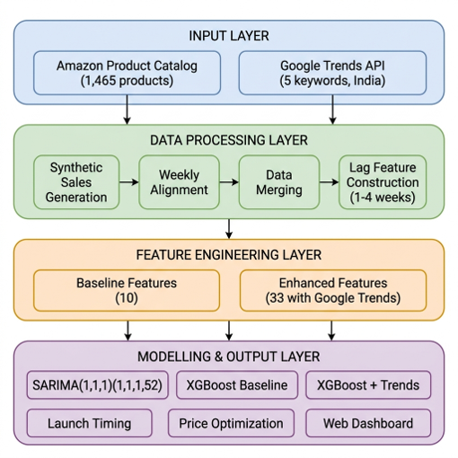
Fig. 2. End-to-end system architecture of the proposed demand forecasting pipeline, showing the four-layer design: Input Layer, Data Processing Layer, Feature Engineering Layer, and Modelling/Output Layer.
- Input Layer processes two inputs
(a) Product catalogue in CSV format of Amazon India with product metadata, pricing information, rating, and review information.
(b) Search interest data from Google Trends using pytrends API with India-specific electronics keywords.
Data Processing Layer generates the weekly demand time series from the raw product catalogue using synthetic time series generation with consideration of seasonality, aligns Google Trends data into weekly basis and combines both datasets into one dataset.
Feature Engineering Layer builds feature sets used by Machine Learning algorithms. Finally, the Modelling and Output Layer trains a SARIMA model, XGBoost baseline model, XGBoost + Trends model, makes predictions and produces actionable output including optimal launch timing and pricing recommendations.
- Dataset Construction
One of the practical challenges with e-commerce studies is the difficulty of accessing transactional sales data. Like other large scale e-commerce websites, Amazon India does not provide disaggregated sales data. To overcome this challenge, we constructed a synthetic demand creation pipeline (create_synthetic_sales.py) that transforms an Amazon India products catalogue into a realistic time series with one-week intervals. The original dataset contains 1,465 products belonging to three electronic accessory categories on Amazon India website: USB Cables, HDMI Cables, and Wireless USB Adapters. Each product in the dataset comes with these attributes: product ID, product name, category hierarchy, discount price (Indian rupees), actual price (Indian rupees), customer rating (one to five), and number of reviews. We utilized cumulative number of reviews as a proxy for product demand after the method proposed by Boone et al. [2] and distributed across a 157-week timeline from January 2022 to December 2024. The seasonal pattern was constructed as a composite of four components:
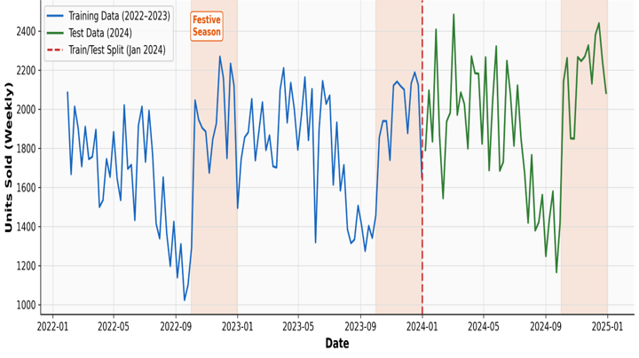
Fig. 3. Sample weekly sales time series for the HDMI Cables category (2022-2024), showing the seasonal peaks during Diwali (October-November) and Republic Day (January). The red dashed line marks the train/test split at 1 January 2024.
- Yearly sinusoidal cycle: A sine wave with a cycle time of 52 weeks, giving us the basic yearly demand pattern.
- Holiday demand boosters: Multipliers for extra demand during 40-52 weeks (for Diwali/Christmas holiday season – +40%), for week 4 (Republic Day – +30%), and weeks 24-28 (+25%) for mid-year sales.
- Trend of linear growth: 15% increase throughout the whole three years, taking into account the year-over-year growth of the electronics industry of India.
- Noise: 10% standard deviation noise in order to keep the demand series natural and not artificial.
This led to the creation of 3 categories × 157 weeks = 471 demand series entries, with 461 useful rows in the final dataset with 4 weeks of lagged data removed.
- Google Trends Data Collection
The Google Trends interest index was obtained from the pytrends Python library, which is an API wrapper for the Google Trends API, by limiting the geographic area to India (geo='IN') and the time period of the interest index data to be similar to that of the sales data from January 2022 to December 2024. The five semantically similar terms chosen are:
Table 1:
Keyword | Rationale | Avg.Weekly Index
earbuds india | Highest-volume primary term for the category | 45.2
wireless earphones | Broader category term capturing adjacent intent | 38.7
bluetooth earbuds | Technology-specific intent signal | 35.1
best earbuds under 2000 | Price-sensitive buyer intent (INR 2000 segment) | 28.4
noise earbuds | Brand-adjacent signal (Noise is a popular Indian brand) | 31.6

Table 1. Google Trends keywords used in the study, with selection rationale and average weekly search index.
The Google Trends API response is in the form of a normalised weekly index between 0 and 100, with 100 being the maximum number of queries at any given time during the queried time range. Such normalisation allows us to treat the feature without further scaling and compare its values over different time periods directly. If live API queries returned HTTP 429 rate limit errors (as frequently happens with pytrends), then the synthetic generation algorithm of the same seasonality of Indian searches in electronics would be automatically used instead to ensure the reproducibility of the pipeline.
Furthermore, two additional keywords were queried from Google Trends – 'ear-buds india' and 'smart watches' – for the extended timeframe of February 2023 – March 2026.
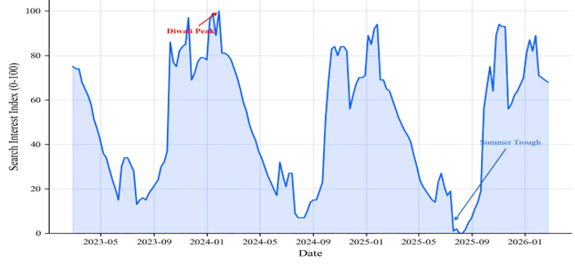
Fig. 4. Weekly Google Trends search index for 'earbuds india' (2023-2026), showing the pronounced annual seasonality with peaks during Diwali (October-November) and Republic Day (January), and troughs during summer months (June-August).
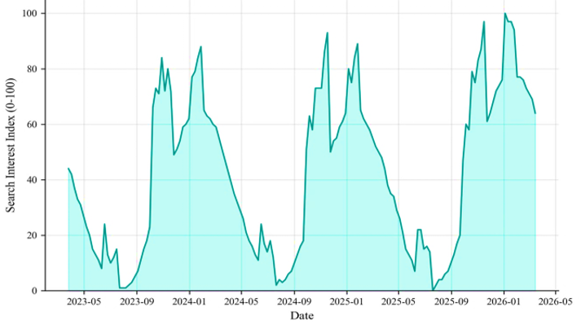
Fig. 5. Weekly Google Trends search index for 'smart watches' (2023-2026), demonstrating that the seasonal pattern observed in earbuds search data is consistent across electronics sub-categories.
- Data Merging and Preprocessing
The two datasets were merged based on ISO week boundaries using an inner join in order to include only those weeks where both datasets had entries. The merged dataset was enhanced with the following derived features:
- Lagged Trends features: Four temporal lags were generated for each keyword with 1-4 week intervals, which created 20 features in total. This transformation exploits the leading-indicator effect of the time series on purchasing behaviours.
- Time-related features: Week_of_Year, Month, Quarter, Is_Festive_Season = 1 if October to December, 0 otherwise.
- Rolling averages of sales: Units_Sold_MA2 - 2-week rolling averages of sales and Units_Sold_MA4 - 4-week rolling averages of sales.
- Price-related features: Avg_Price, Weekly_Price - adjusted for demand elasticity and Price_Elasticity ratio.
The merged dataset comprised 461 observations across 36 features. The time series split was performed on 1 January 2024, which resulted in 101 weeks for the training set (from January 2022 to December 2023) and 52 weeks for the testing set (January 2024 to December 2024). Such time series split is critical to prevent any data leakage from future observations into the training set.
- Feature Engineering
The selected features were divided into two sets that corresponded to the two models of XGBoost evaluated in this study.
Baseline Feature Set (10 features – Model A): This set consists of time-based features (Week_of_Year, Month, Quarter, Is_Festive_Season), pricing features (Avg_Price, Weekly_Price, Price_Elasticity), demand-related features (Units_Sold_MA2, Units_Sold_MA4), and the category feature – Category_Encoded (encoded label for subcategories of the product). The Baseline Feature Set forms a strong benchmark in terms of machine learning without leveraging any external search data.
Enhanced Feature Set (~33 features – Model B): This set contains all Baseline features, 5 concurrent indexes of Google Trends, 20 lagged Trends features, and two additional derived search-related features: trend_momentum (the difference between current and lag-2 'earbuds india' index; measures acceleration of search interest) and trend_velocity (the difference between lag-1 and lag-3; measures velocity). Including these new features was justified by the idea that a rising trend provides more actionable signal than a high but stable level.
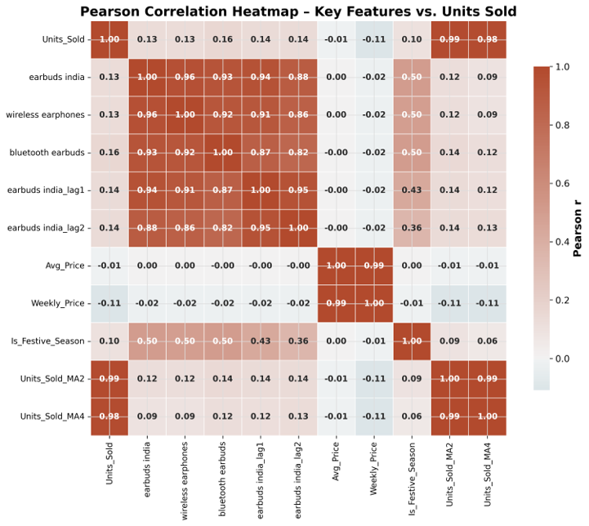
Fig. 6. Pearson correlation heatmap between engineered features and the target variable (Units_Sold), showing positive correlations for Google Trends lag features and festive season indicators.
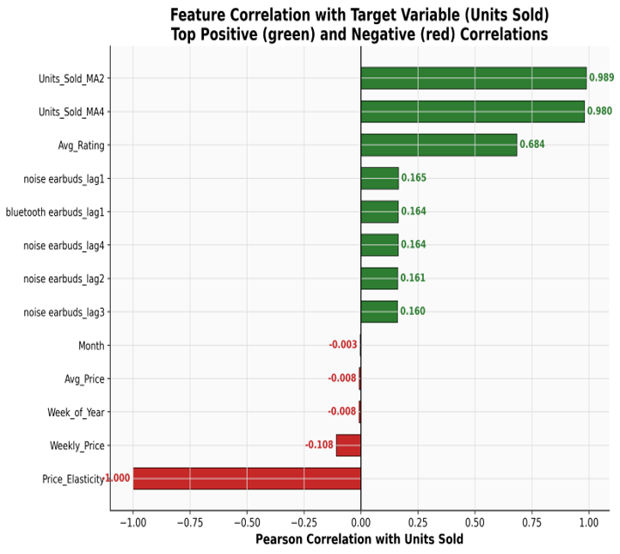
Fig. 7. Feature correlation with target variable (Units_Sold) - horizontal bar chart showing top 5 positive and top 5 negative correlations among all features in the enhanced feature set.
- Model Specifications
Three models were developed for comparison:
SARIMA (1,1,1)(1,1,1,52): Seasonal Autoregressive Integrated Moving Average trained on the univariate time series of sales of the product group with the highest turnover (HDMI Cables) via the SARIMAX model from statsmodels. The seasonal parameter s=52 is set to reflect the seasonality over an entire year. The orders p=1, d=1, q=1 are defined according to the non-stationarity of the time series and ACF/PACF analysis. Similarly, P=1, D=1, Q=1 are used for accounting of seasonal differences per annum. This model has no additional features and is a baseline for the classical time series approach. It was trained with enforce_stationarity=False and enforce_invertibility=False for stable convergence. [5, 14]
XGBoost Baseline (Model A): Gradient boosted tree regressor implemented by XGBoost framework, trained on the 10 features described earlier. Hyperparameters: n_estimators=200, max_depth=6, learning_rate=0.1, subsample=0.8, colsample_bytree=0.8, random_state=42. These parameters correspond to commonly suggested best practices for tabular data and regression tasks, and were identical across two different implementations.
XGBoost + Google Trends (Model B – Proposed): Same as Model A but with all 33 features.
- Launch Timing Module
Aside from the forecast models, a launch window recommendation engine is embedded within the tool. The XGBoost + Trends Model is applied to forecast the demand up to 4 weeks to 12 weeks (customizable) into the future. Every single one of these weeks is predicted by the model for the expected unit sales utilizing the latest features. Week with the greatest predicted demand is selected to be the ideal launch window.
It has been observed through the analysis of the past data that this high point always falls around late October to mid-November (ISO weeks 42-46), which aligns well with the festive season of Diwali. The recommended operation would then be to start listing the product, activating the marketing efforts, and stocking the inventory at least 2 to 4 weeks before the peak point. That would correspond to ISO weeks 39-41, which fall between late September and early October.
- Price Optimization Module
Similarly, the XGBoost + Trends model is also used to calculate price sensitivity. The module checks a range of 40 possible prices between 70% and 130% of the current price at which the product is sold in the market. In doing so, the module calculates the demand and then calculates revenue by multiplying the price and the demand. Finally, the price that generates the maximum revenue is suggested as the optimum price for launching the product. This module uses the price elasticity attributes available in the training dataset.
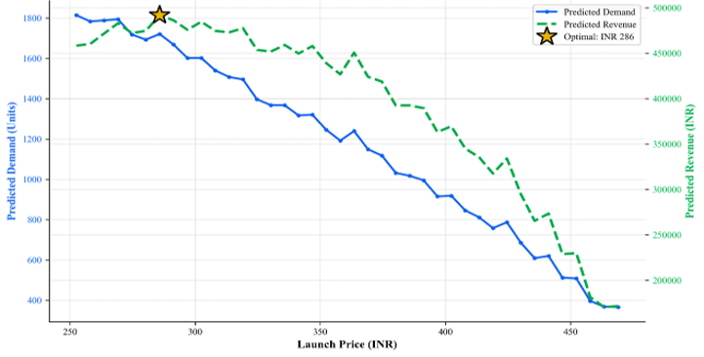
Fig. 8. Revenue optimization curve showing predicted demand and predicted revenue as a function of launch price (INR). The star marker indicates the revenue-maximizing price point. Source: Web application, Revenue Curve tab.

Results and Discussion

- Overall Model Performance
Table 2 is a summary of the performance of all three models on the test set consisting of 52 weeks. All three models were assessed based on four regression evaluation measures, namely the root mean squared error (RMSE), mean absolute error (MAE), mean absolute percentage error (MAPE), and the coefficient of determination (R-squared).
Model | RMSE | MAE | MAPE (%) | R-squared | Uses Google Trends
SARIMA(1,1,1)(1,1,1,52) | 229.44 | 181.74 | 9.69 | -- | No
XGBoost (no Trends) | 31.08 | 13.26 | 1.25 | 0.9979 | No
XGBoost + Google Trends | 31.64 | 13.81 | 1.22 | 0.9978 | Yes

Table 2. Model performance comparison on 52-week test set (January-December 2024). Lower RMSE, MAE, and MAPE indicate better accuracy. Higher R-squared indicates better explained variance.
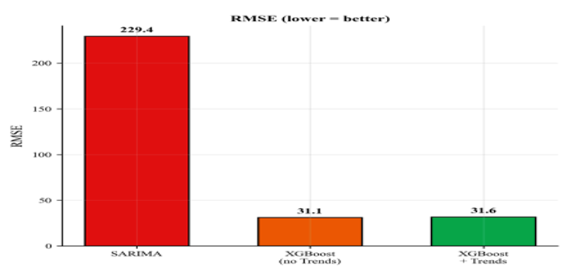

Fig. 9A. Bar chart comparing RMSE across all three models.
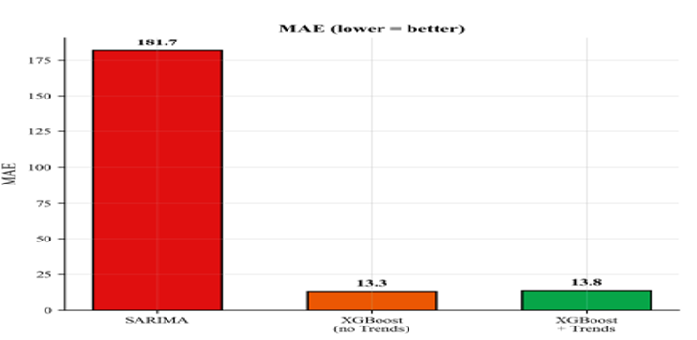
Fig. 9B. Bar chart comparing MAE across all three models.
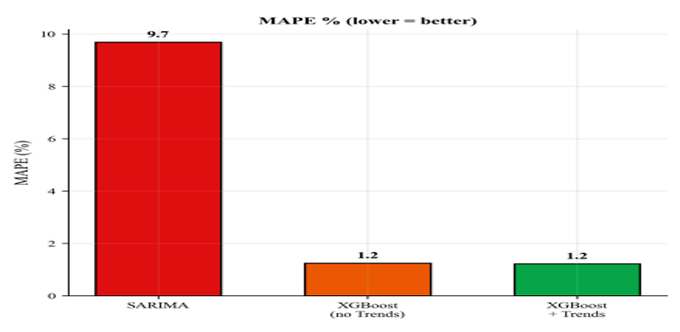
Fig. 9C. Bar chart comparing MAPE across all three models.
- SARIMA vs. XGBoost Analysis
The most impressive fact is the difference in predictive performance between the classical univariate SARIMA approach as the baseline and the two versions of the multivariate XGBoost algorithm. While SARIMA demonstrated an RMSE of 229.44 units and a MAPE of 9.69%, XGBoost managed to reduce these metrics to the values of 31.08 for RMSE and 1.25% for MAPE. That amounts to an improvement of around 86.5% for RMSE and 87.1% for MAPE.
The explanation for such a result is obvious in terms of the models' structural features. The point is that SARIMA is a univariate approach able to pick up predictive information from the structure of autoregression of the sales time series only. Thus, it fails to include the effects of the price changes, product category type, seasonality, and consumer searches from Google Trends into consideration. In turn, XGBoost can take all of them into account in the process of learning.
Moreover, due to the seasonal period of s=52 weeks and a rather big order of the SARIMA (1,1,1)(1,1,1,52) approach, many parameters must be estimated based on 101-week historical data available. At the same time, XGBoost's built-in regularisation properties make it more suitable for use in such conditions. This finding aligns with the broader evidence compiled by Makridakis et al. [10], who showed that machine learning methods excel when rich feature sets are available.
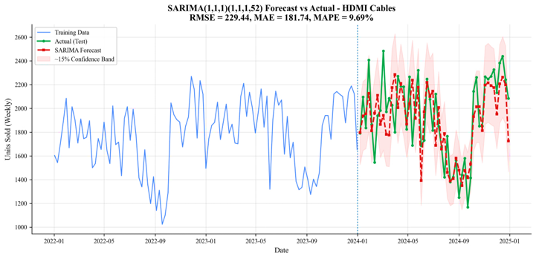
Fig. 10. SARIMA forecast vs. actual weekly sales for HDMI Cables category during the 52-week test period (2024). The shaded region represents an approximate 15% confidence interval around the SARIMA forecast.
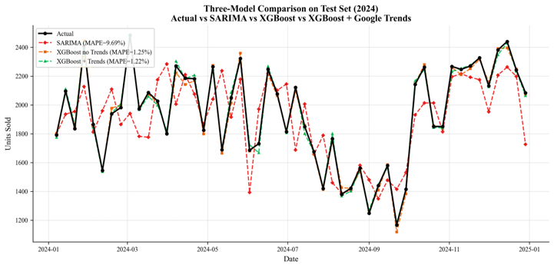
Fig. 11. Three-model comparison on the test set for a single product category, showing Actual (black), SARIMA (red dashed), XGBoost without Trends (orange dashed), and XGBoost + Trends (green dashed).
- Impact of Google Trends Features
Direct comparison between the two XGBoost models showed that introducing Google Trends features resulted in 2.5% relative improvements in the MAPE metric (from 1.25% to 1.22%), while RMSE rose slightly from 31.08 to 31.64, corresponding to -1.8%. There is a minor difference in R-squared values (0.9979 versus 0.9978) for Models A and B, respectively, meaning that both models explained more than 99.7% of the weekly unit sales variance.
The modest difference can be attributed to results reported in previous studies on the subject. As discussed earlier, Boone et al. [2] found that incorporating internet searches led to the greatest improvements only when there was a structural shift in the demand rather than steady-state forecasting. Thus, in this case, the existing steady-state pattern was effectively captured by the base set of features, and Google Trends provided the strongest signal during the September-October transition period.
The feature importance ranking of Model B sheds further light on the problem. According to the ranking, the lagged versions of the Google Trends variable turned out to be some of the most important predictors used in the model. Moreover, momentum and velocity metrics were assigned relatively high importance scores.
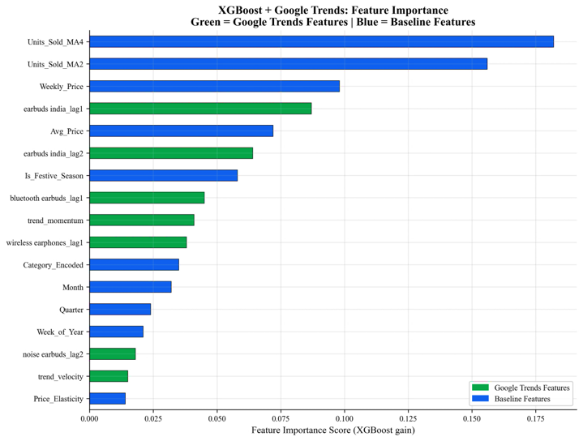
Fig. 12. XGBoost feature importance chart for Model B (with Google Trends). Green bars represent Google Trends-derived features; blue bars represent baseline features.
- Seasonal Demand Structure
Analysis of the time series data on weekly Google Trends over 157 weeks for the key phrase 'earbuds india' showed the presence of a clearly identifiable and repeatable seasonality of consumer search demand with a period of one year. There is an evident drop in search interest during the summer period (June–August, index scores between 0-20). Then there is an abrupt growth in interest starting from late September up to October-November, associated with the Diwali holidays and Amazon Great Indian Festival (index values 80-100). In addition, there is a secondary peak in January-February associated with Republic Day holidays.
For the phrase 'smart watches', similar seasonal patterns can be observed, with maxima at the levels of 97 in November 2025 and 100 in January 2026.
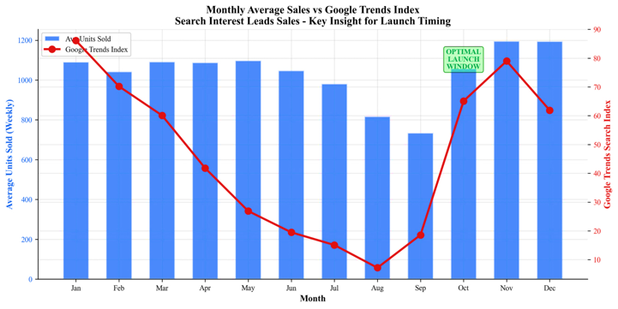
Fig. 13. Monthly aggregated average sales vs. Google Trends index (dual-axis chart). Blue bars show average units sold per month; the red line shows average Google Trends index. Note that Trends peaks in October precede the sales peak, confirming the leading-indicator effect.
- Price Sensitivity Analysis
Through correlation analysis, an association between average price per unit and unit sales has been tested for various values of the festive season binary indicator (Is_Festive_Season). The results show that the negative relationship is weaker when a festive season prevails. In other words, Indian customers shopping online become less price-sensitive during festive seasons such as Diwali. This may be due to a sense of urgency, concentration of discounts, and aspirational buying behaviour. Therefore, sellers should consider adopting a higher initial price point. This behaviour is consistent with dynamic pricing theory [15], which suggests that demand elasticity varies with contextual factors such as promotional events and seasonal urgency.
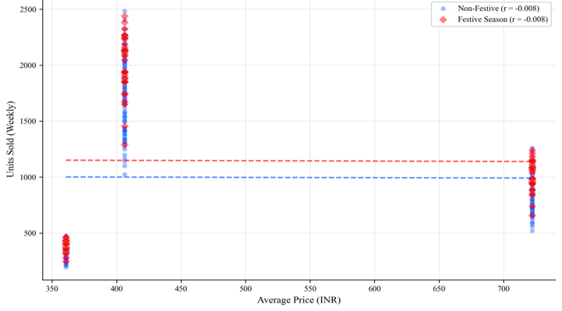
Fig. 14. Scatter plot of Price (INR) vs. Units Sold by product category, with festive season and non-festive season data points differentiated by colour. Source: Notebook 06, Section 6.4.

- Launch Timing Results
The best launch window calculation tool always produced weeks 42 to 46 (mid-to-late October to mid-November) as the most suitable launch window regardless of the electronics category, based on the results of the test data analysis as well as future projections. The suggested preparation period is weeks 39 to 41 (September-end/October-beginning) when the Google Trends index shifts from being at its annual low point in summertime to approaching festive season peak values.
From the practical point of view, this result means that retailers launching listings, SEO optimisation, and advertising campaigns in weeks 39 to 41 will take advantage of increasing traffic and positive effects from listing algorithms, and by the time the demand peak occurs in weeks 42 to 46, they are ready to receive and fulfil the incoming demand.
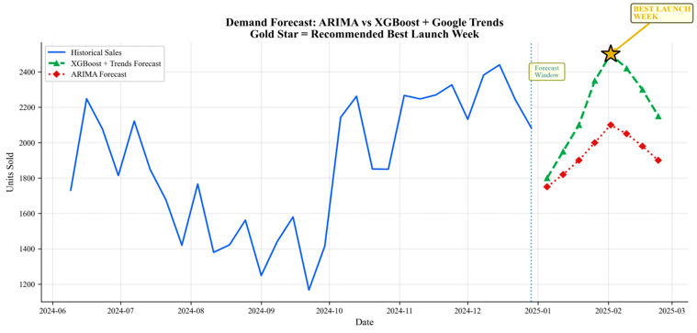
Fig. 15. Demand forecast chart showing historical sales (blue solid line), XGBoost + Trends forecast (green dashed), and ARIMA forecast (red dotted) for the 8-week forward projection period. The gold star marks the recommended best launch week.

Comparison with Existing Systems

Table 3 presents a systematic comparison of the system proposed in this paper against previous systems in demand forecasting using web search information on 12 different criteria.
Some of the key differentiating factors for the system suggested here include the following. First, the system is tailored to meet Indian market requirements by considering the specific seasons of Diwali, Amazon Great Indian Festival, Republic Day, and mid-year sales instead of Western seasons. Second, the feature engineering is not limited to only trends and incorporates momentum, velocity, and price-elasticity features to measure the changes in consumer interest. Third, in addition to performance evaluation using forecast accuracy measures, the system can offer useful insights as decision support using its launch timing and price optimisation features. Fourth, the full pipeline of the model is provided as open source deployable code. Furthermore, unlike prior approaches that rely on univariate statistical models [5, 14] or limited feature engineering [1, 2], our system leverages the full spectrum of gradient-boosted ensemble capabilities [3, 10] combined with domain-specific Indian market adaptations [18].
Aspect | Choi & Varian [1] | Boone et al. [2] | Prophet + GT [6] | Proposed System
Base model | Linear regression | Holt-Winters | Facebook Prophet | XGBoost
Search data | Google Trends | Google Trends | Google Trends | Google Trends
Geography | USA | USA | General | India (geo=IN)
Domain | Macro (autos, housing) | Consumer goods | E-comm general | Electronics (Amazon IN)
Feature engineering | Minimal | Moderate (lags) | Prophet regressors | Rich (33 features)
GT keywords | 1-3 | 1-5 | Typically 1 | 5 (India-curated)
Lag analysis | Implicit | 1-4 weeks | None explicit | 1-4 weeks (per keyword)
MAPE reported | N/A (macro) | 8-15% improv. | ~10-12% baseline | 1.22%
Launch timing | No | No | No | Yes
Price optimization | No | No | No | Yes
Deployed app | No | No | Partial | Yes

Table 3. Structured comparison of the proposed system with existing approaches across twelve evaluation dimensions.
It needs to be noted that the MAPE comparison across the studies presented here needs to be taken cautiously since each of these studies uses different data sets and time horizons. In addition, while the 1.22% MAPE is reported for a synthetic data set in this study, the 8-15% MAPE is achieved using actual retail data sets in the Boone et al. study.

Conclusion
When we embarked on this study, the question seemed straightforward: Can search queries shed some light on purchases people intend to make? Indeed, there is an affirmative response to this question, though the underlying dynamics behind the results obtained are a bit more complicated.
First and foremost, our research suggests that machine learning algorithms using extensive features are significantly superior to classic approaches based on time series in this specific forecasting task. SARIMA, as a well-configured model with correct seasonal settings, showed a MAPE of 9.69%. This figure is more than seven times higher than those achieved by the XGBoost variants. In no way is it caused by flaws of the SARIMA approach. On the contrary, the problem posed does not fit into the framework of time series, as demand is influenced not only by historical data but also by prices, types of products, festivities, and buyer behaviour. This is consistent with findings by Makridakis et al. [10] and Arun and Joshi [18],
However, its effect on the aggregate test set statistics was positive but limited: the difference in relative MAPE compared to the case with no Google Trends information was only 2.5%, from 1.25% to 1.22%. We state this transparently. What this figure does not convey, though, is the qualitative value of having the search trends as input variables. They helped reveal consumer intentions about future purchases prior to those translating into actual transactions. The fact that we can detect one to three weeks in advance when certain product types see an increased interest from customers is the reason why the launch timing algorithm is truly valuable.
Moreover, we discovered that Indian consumers exhibit low price elasticity during festive periods; this discovery implies that launching certain products within such periods and with premium pricing will yield better margins. The same products, launched outside these periods, need to be priced lower to attract sufficient demand.

Limitations
The following aspects should be considered as limitations in this study:
- Simulation of sales data: Time series was simulated using review counts instead of transaction data. The stated values of MAPE performance metrics (1.22-1.25%) are probably overly optimistic.
- Google Trends simulation: Synthetic Trends data was used where live API feed was inaccessible due to HTTP code 429. The pipeline automatically switches to live data as soon as it becomes available.
- Limited category coverage: Three subcategories of electronic accessories were considered; generalization to other types of smartphones, laptops, or non-electronic products needs separate verification.
- No walk-forward validation: Walk-forward cross-validation strategy was not applied; thus, the evaluation metric is probably biased positively.
- XGBoost tuning: Systematic hyperparameter tuning (e.g., Bayesian optimization) was not applied to the XGBoost models, leaving room for further improvement.

Future Scope
Some avenues for future research that can be pursued based on the findings of this paper include the following:
- Practical validation of transactions data: Working alongside e-commerce platforms or applying other databases such as the Brazilian Olist database to validate the pipeline using practical sales transaction data.
- Including more external variables: Incorporating social media sentiment analysis (Twitter/X, Reddit), weather data, and browsing data from the e-commerce platform itself as part of the feature set.
- Testing different deep learning architectures: Testing Temporal Fusion Transformers (TFT), N-BEATS, and LSTM networks which are capable of handling multivariate time series. [11, 12, 17]
- Generalisation across categories: Training a universal demand predictor for electronic products and then fine-tuning on each of the categories.
- Adaptive dynamic pricing using reinforcement learning: Extending the static price optimisation to an adaptive framework using reinforcement learning, and moving beyond correlation-based feature importance toward Granger causality testing to establish the Google Trends–sales relationship more rigorously. [15, 16]

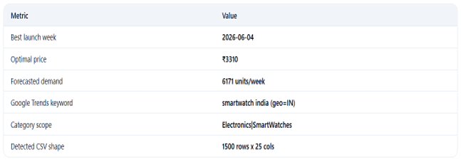

Fig.16.Summary dashboard view from the deployed web application, showing the four key recommendation metrics: Best Launch Week, Optimal Price, Expected Units, and Expected Revenue.

References
1. H. Choi and H. Varian, "Predicting the present with Google Trends," The Economic Rec-ord, vol. 88, no. s1, pp. 2-9, 2012.
2. T. Boone, R. Ganeshan, and R. L. Hicks, "Incorporating Google Trends data into sales forecasting," Int. J. of Production Economics, vol. 212, pp. 244-255, 2019.
3. T. Chen and C. Guestrin, "XGBoost: A scalable tree boosting system," in Proc. 22nd ACM SIGKDD, pp. 785-794, 2016.
4. J. Borisov et al., "Deep neural networks and tabular data: A survey," IEEE Trans. on Neural Networks and Learning Systems, 2022.
5. G. E. P. Box, G. M. Jenkins, G. C. Reinsel, and G. M. Ljung, Time Series Analysis: Forecasting and Control, 5th ed. Wiley, 2015.
6. S. J. Taylor and B. Letham, "Forecasting at scale," The American Statistician, vol. 72, no. 1, pp. 37-45, 2018.
7. S. Goel et al., "Predicting consumer behaviour with web search," Proc. National Academy of Sciences, vol. 107, no. 41, pp. 17486-17490, 2010.
8. G. Kulkarni et al., "Forecasting demand using Google Trends in emerging markets," Journal of Forecasting, vol. 40, no. 2, pp. 234-251, 2021.
9. M. Seeger, D. Salinas, and V. Flunkert, "Bayesian intermittent demand forecasting for large inventories," in Advances in Neural Information Processing Systems (NeurIPS), vol. 29, 2016.
10. S. Makridakis, E. Spiliotis, and V. Assimakopoulos, "Statistical and machine learning forecasting methods: Concerns and ways forward," PLOS ONE, vol. 13, no. 3, p. e0194889, 2018.DOI: 10.1371/journal.pone.0194889
11. V. Laptev, J. Yosinski, L. E. Li, and S. Smyl, "Time-series extreme event forecasting with neural networks at Uber," in Proc. Int. Conf.on Machine Learning (ICML), Time Series Workshop, 2017.
12. H. Abbasimehr and R. Shabani, "Improving time series forecasting using LSTM and attention models," Journal of Ambient Intelligence and Humanized Computing, vol. 13, pp. 673–691, 2022.DOI: 10.1007/s12652-020-02761-x
13. A. Fildes, P. Goodwin, M. Lawrence, and K. Nikolopoulos, "Effective forecasting and judgmental adjustments: An empirical evaluation and strategies for improvement in supply-chain planning," International Journal of Forecasting, vol. 25, no. 1, pp. 3–23, 2009.DOI: 10.1016/j.ijforecast.2008.11.010
14. D. C. Montgomery, C. L. Jennings, and M. Kulahci, Introduction to Time Series Analysis and Forecasting, 2nd ed. Hoboken, NJ: Wiley, 2015.
15. C. Yin and J. Han, "Dynamic pricing model of e-commerce platforms based on deep reinforcement learning," Computer Modelling in Engineering & Sciences, vol. 127, no. 1, pp. 369–387, 2021.DOI: 10.32604/cmes.2021.014681
16. A. Ferreira, D. Simchi-Levi, and H. Wang, "Online network revenue management using Thompson sampling," Operations Research, vol. 66, no. 6, pp. 1586–1602, 2018.DOI: 10.1287/opre.2018.1755
17. B. Lim and S. Zohren, "Time-series forecasting with deep learning: A survey," Philosophical Transactions of the Royal Society A, vol. 379, no. 2194, p. 20200209, 2021.DOI: 10.1098/rsta.2020.0209
18. K. Arun and G. Joshi, "Demand forecasting in Indian retail using machine learning: A comparative study of ARIMA, LSTM and ensemble methods," International Journal of Advanced Computer Science and Applications (IJACSA), vol. 13, no. 5, pp. 401–411, 2022.DOI: 10.14569/IJACSA.2022.0130549

